**Continuous Integration / Continuous Pipeline Lab**

1. Creating Project On CodeStar

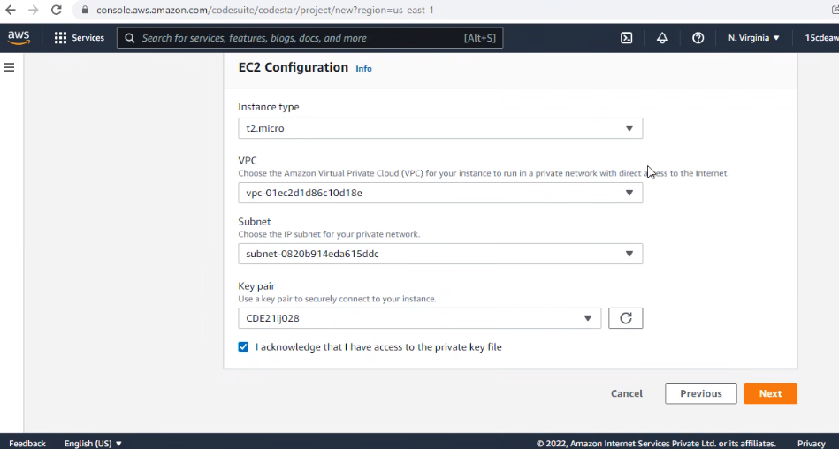

1. Provisioning Project

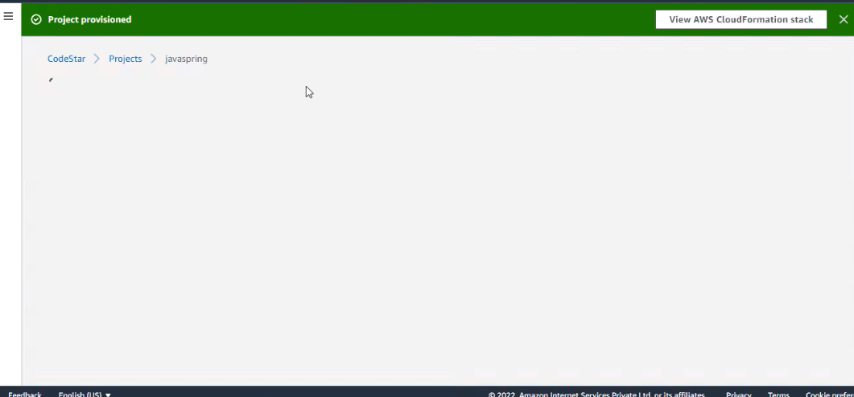

1. Configuring Amazon Cloud9 IDE.

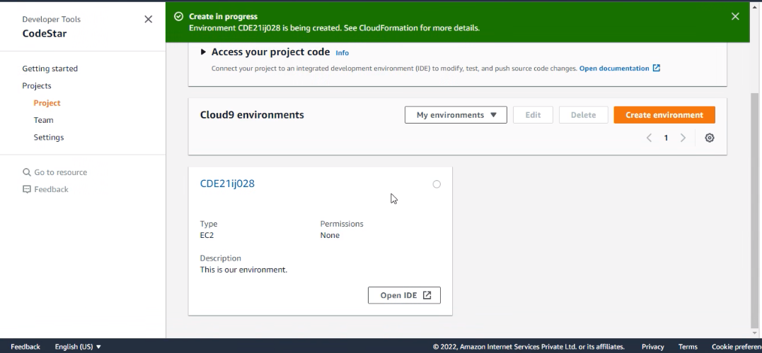

1. CICD Pipeline

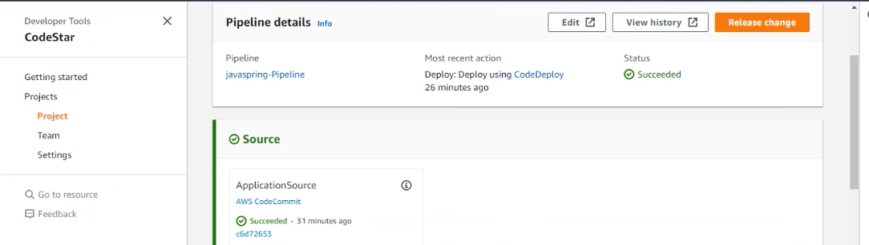

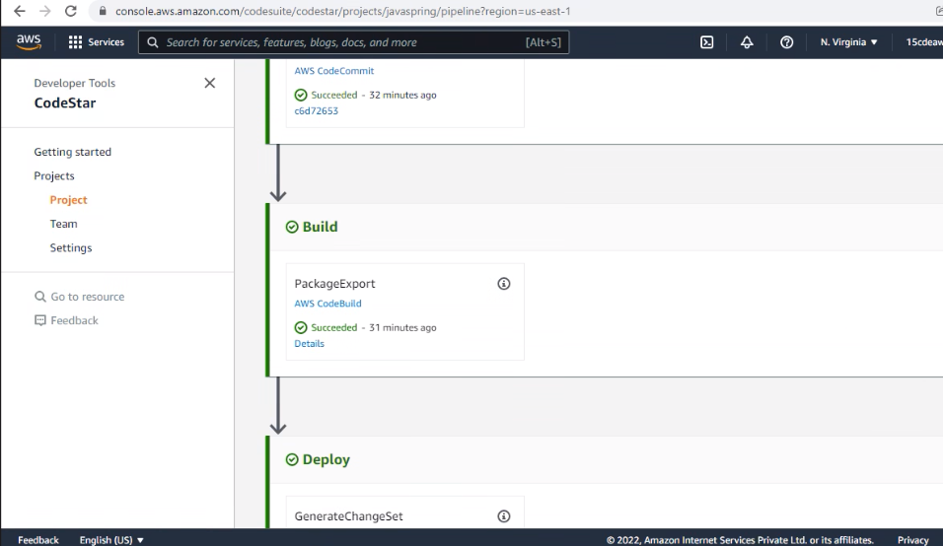

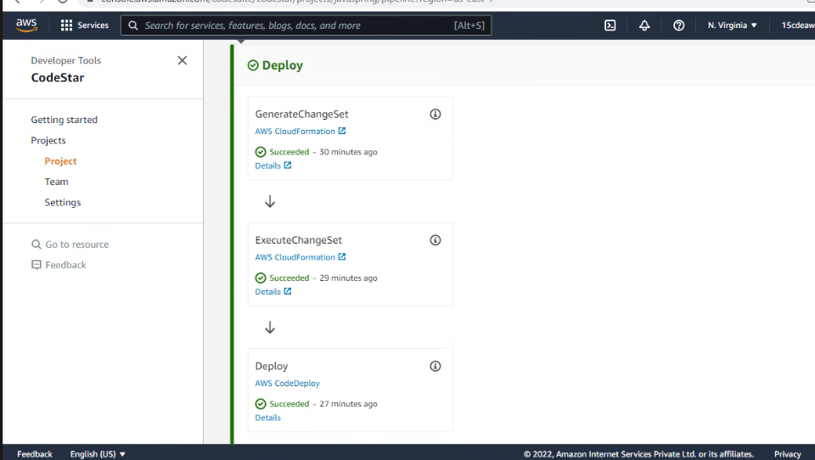

1. Launching the created spring web application on web.

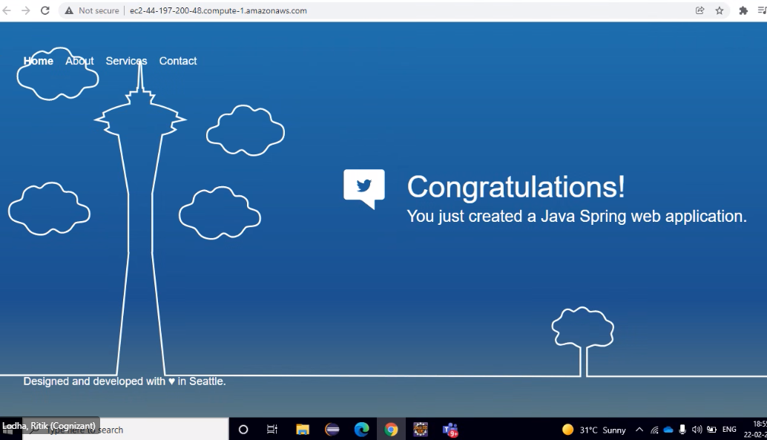

1. Making changes in the index.jsp file.

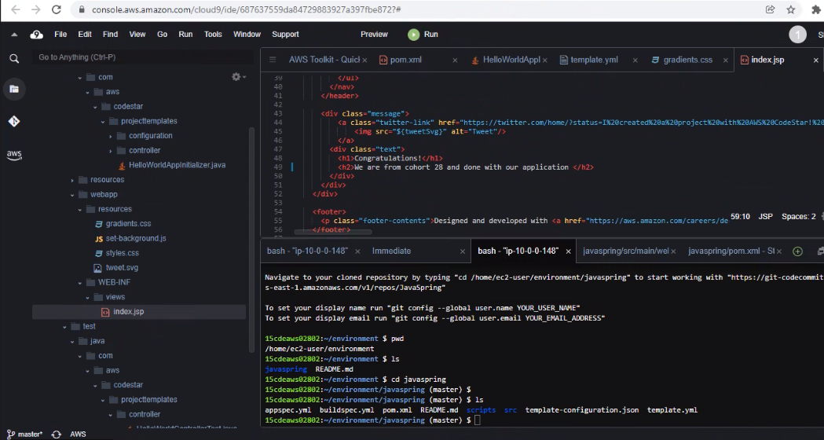

1. Committing the saved changes to AWS Cloud Commit.

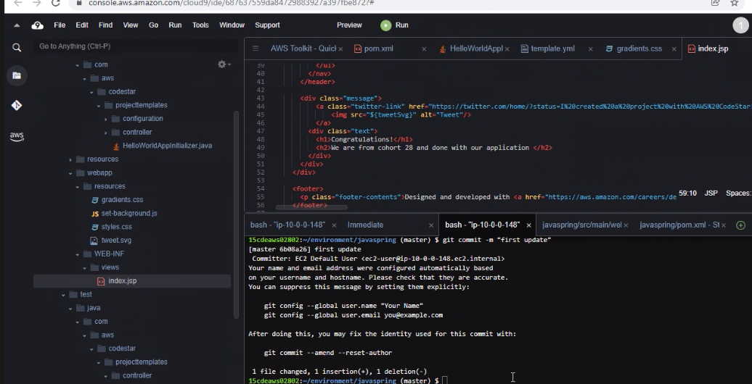

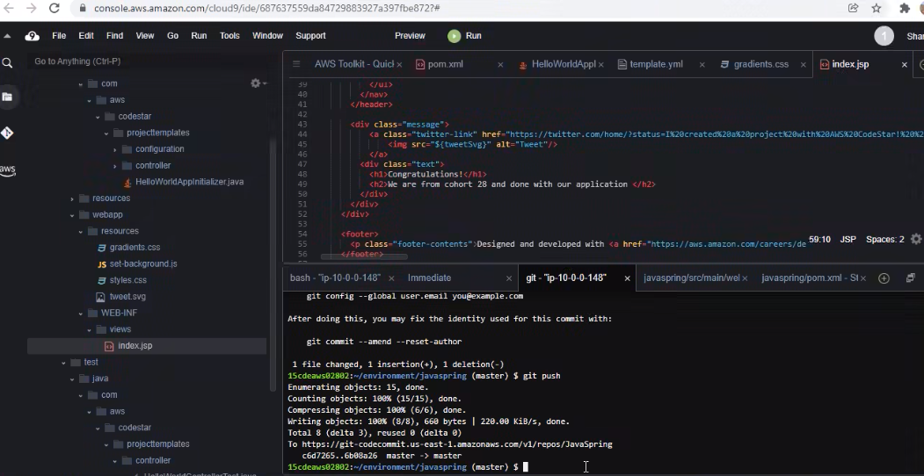

1. Again running the application after pushing the code to the Aws Cloud Commit repository and seeing the changes.

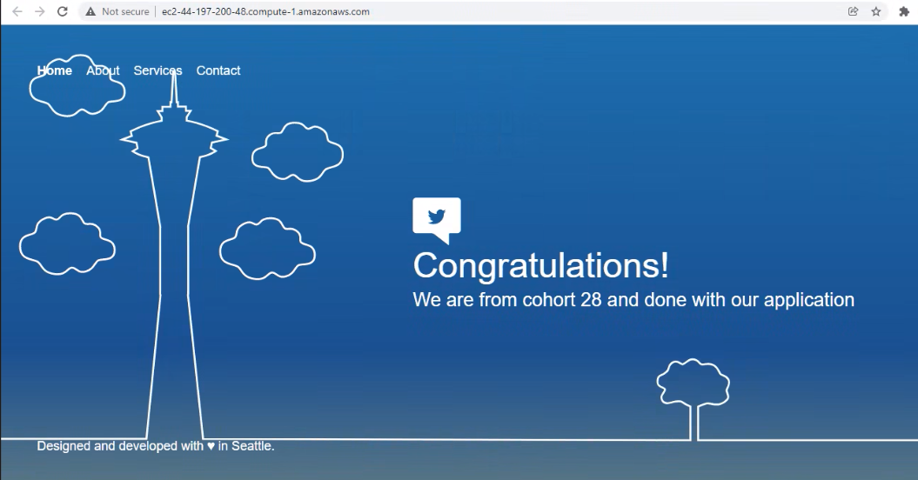

Thank you…